--Fatal Crashes  January 29, 2019 – February 5, 2019:

                            - 1/29/18: Londonderry, VT 11.  Two vehicle crash, driver fatality.  Seatbelt used.

--**2019** Fatalities: **2**   Total – **2** vehicle operators, **0** passengers, **0** pedestrians

--**2018** Fatalities: **69**   Total – **47** vehicle operators, **16** passengers, **6** pedestrians

**\*\*\*Reminder, these numbers are not yet final.**

|  |  |  |
| --- | --- | --- |
| As of **February 5 in each calendar year shown**: | | |
| Year | Fatalities (People) | Fatal Crashes |
| 2019 | 2 | 2 |
| 2018 | 3 | 3 |
| 2017 | 4 | 4 |
| 2016 | 3 | 3 |

|  |  |  |  |  |  |  |
| --- | --- | --- | --- | --- | --- | --- |
| **Fatal Crash Data** | **2019\*** | **2018\*** | **2017** | **2016** | **2015** | **2014** |
| Total Fatal Crashes | 2 | 61 | 64 | 59 | 50 | 42 |
| Total Fatalities (People) | 2 | 69 | 70 | 64 | 57 | 44 |
| Double Fatality Crashes | 0 | 8 | 3 | 2 | 5 | 2 |
| Triple Fatality Crashes | 0 | 0 | 0 | 1 | 1 | 0 |
| Quadruple Fatality Crashes | 0 | 0 | 1 | 0 | 0 | 0 |
| Operators Suspected as Driving under the Influence of Alcohol Only | 0 | 5 | 6 | 14 | 4 | 3 |
| Operators Suspected as Driving under the Influence of Drugs Only | 0 | 13 | 18 | 10 | 11 | 10 |
| Operators Suspected as Driving under the Influence of both Alcohol & Drugs | 0 | 10 | 11 | 10 | 9 | 3 |
| **Active Cannabis - Delta 9 THC Confirmed\*\*** | **0** | **16** | **18** | **18** | **11** | **9** |
| Operators Suspected of Speeding | 0 | 22 | 27 | 29 | 16 | 14 |
| Operators with Suspended License/ No License | 0 | 7 | 11 | 10 | 5 | 4 |
| Junior License Operators involved in fatal crashes | 0 | 4 | 2 | 0 | 1 | 2 |
| "Older Drivers" involved in fatal Crashes (Older Driver is defined as any person age 65 or older. & “involved” does not imply “fault”) | 1 | 14 | 15 | 14 | 11 | 11 |
| Crashes involving a Large Truck/Bus (“involving” does not imply “fault”) | 0 | 6 | 3 | 5 | 4 | 9 |
| Motorcyclist Fatalities | 0 | 7 | 13 | 11 | 11 | 7 |
| *\*2018 & 2019 data is as of the date of this report.  These numbers are subject to change.* | | | | | | |
| *\*\*Active Cannabis - Delta-9 THC Confirmed is counted in the number of operators that had drugs only or alcohol & drugs.* | | | | | | |

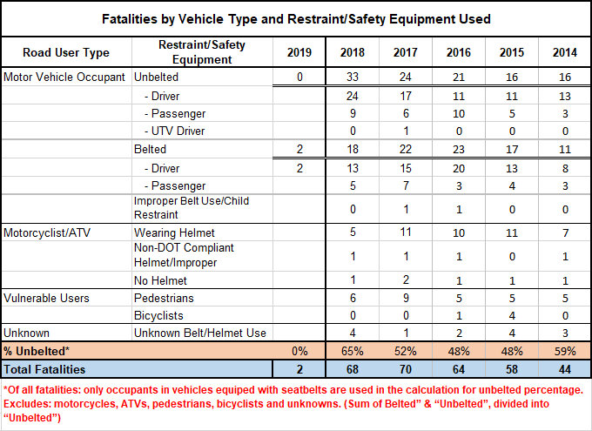

**Mandy White**   
AOT Technician VII & VT FARS Analyst  
VTrans - Office of Highway Safety   
219 North Main St. Suite 201  
Barre, VT 05641  
Phone: (802)595-9341  
Fax: (802)828-3983

**Crash Help Line: (888)374-3011   
Crash Email:** [**AOT.CrashRequests@vermont.gov**](mailto:AOT.CrashRequests@vermont.gov)